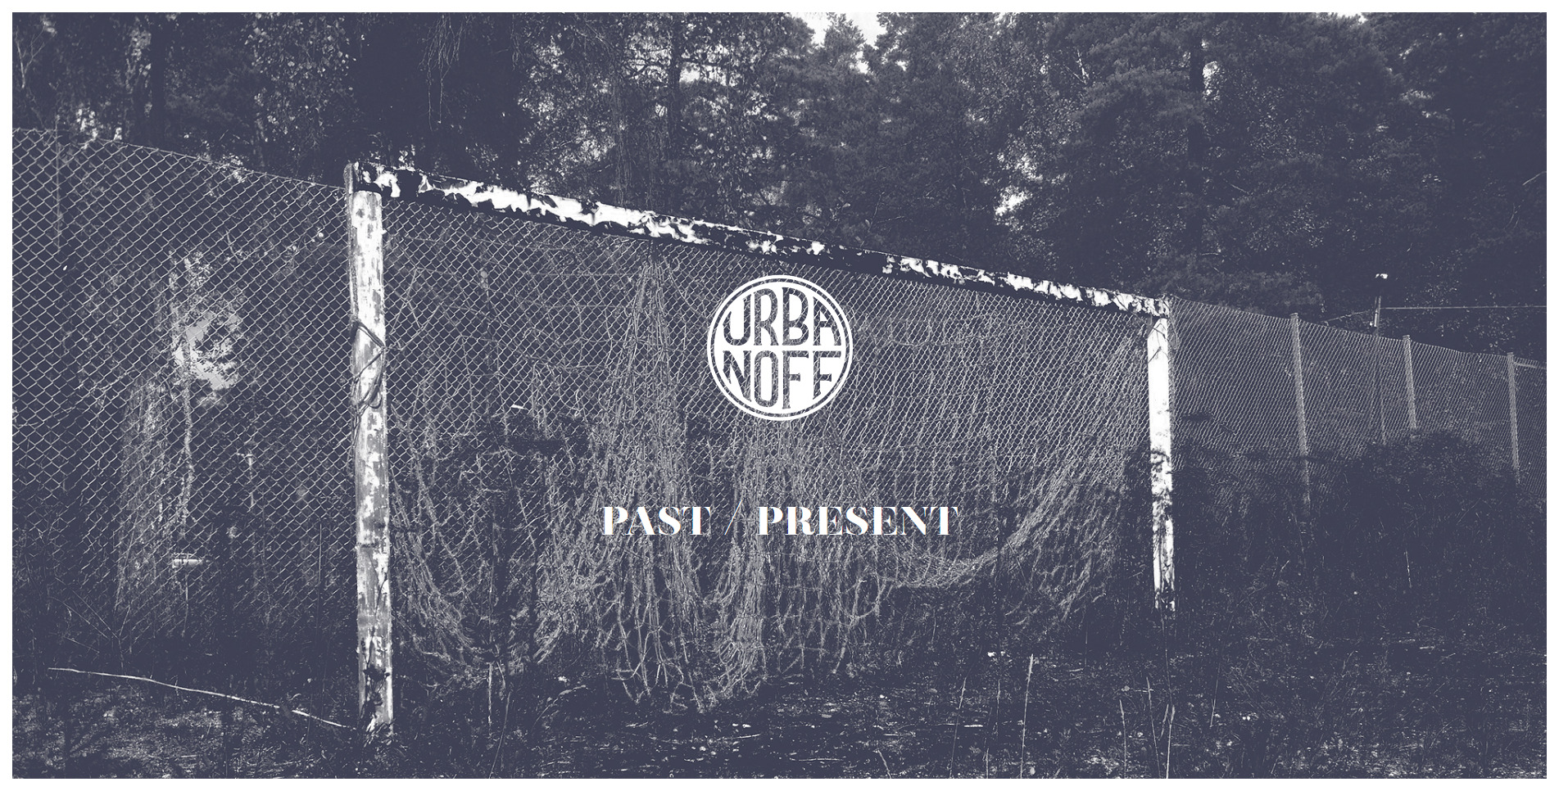

<http://urbanoff.com/>

Color scheme: Monochromatic

This website has a nice blend of washed out grays and blacks. all the actual colors on this site are all washed out or diluted making the overall look of the site very easy on the eyes and gives off a sense of calm like a still ocean.

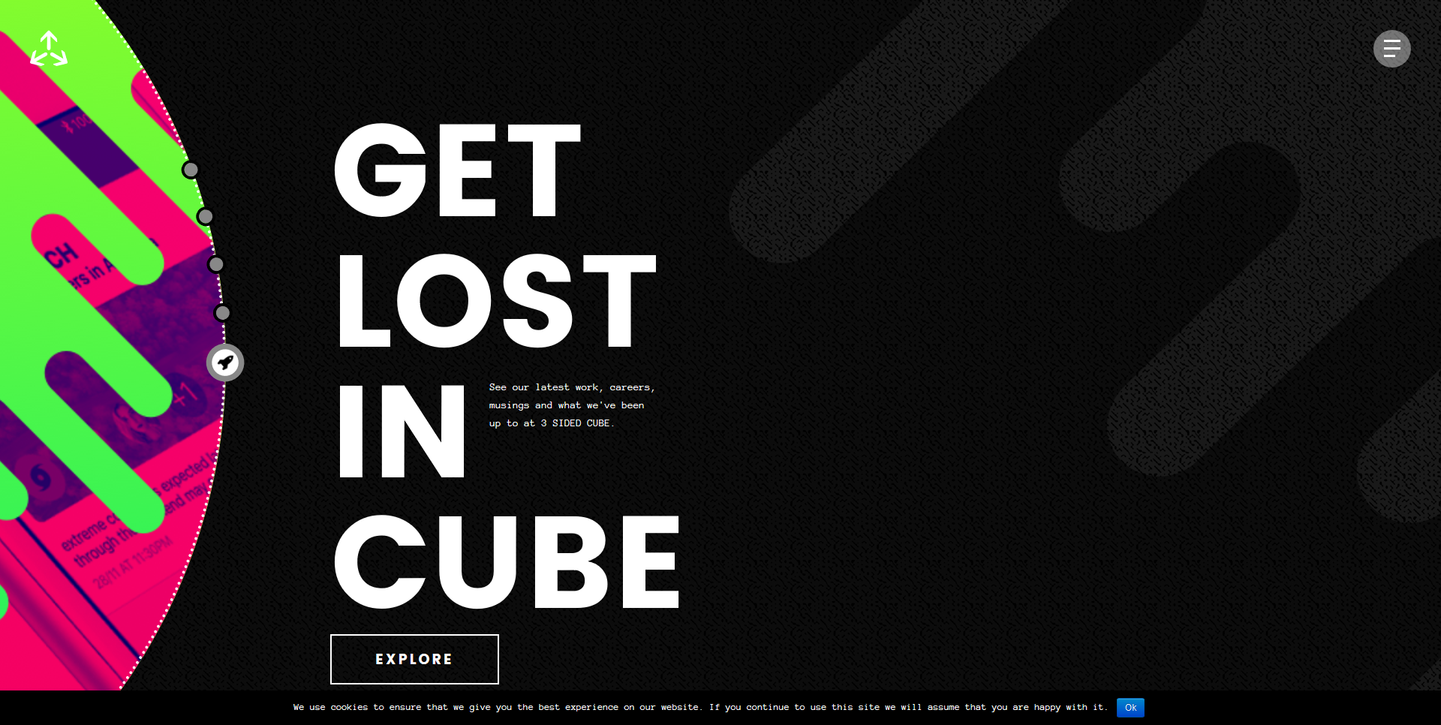

<https://3sidedcube.com/>

Color scheme: analogous

This website is a beautiful amalgamation of design and functionality as the user scrolls down the main page they are greeted by splashes of vibrant colors each one more pleasing than the last.